Bhartiyam International School
Periodic Assessment – 1 (2022-23) Subject: EVS (Set-2)
Class: I
Date: 12/07/2022 Max. Mark: 20
Name: Roll No: Duration: 1 hr

Instructions:
- All the questions are compulsory.
- Attempt all the questions in neat and clean handwriting.
A. Attempt the multiple choice questions. (1X3=3) 1.A card that help others to know you is called the_____________________
a) my card b) play card c) identity card
2. Which of the following parts of our body helps us smell flowers?
- hand b) nose c) eyes
3. Which of the following parts of our body helps us taste food?
a) ears b) tongue c) knee
B. Match the pictures with their spellings. (1X3=3)
1. a) eyes

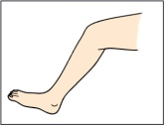

2. b) lips

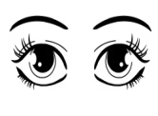
`
3. c) legs

C. Write ‘T’ for true and ‘F’ for false statement. (1X4=4)
1. Ears helps us to hear.

2. Legs help us to eat.

3. Tongue helps us to see.

4. Skin helps us to feel.

D. Fill in the blanks. (1X4=4)

1. Hand help us to .
2. I like to .
3. I go to Bhartiyam International ____________.
4. The things that we like are called our __________________things.
E. Answer the following questions. (2X3=6)
1. How many sense organ do we have?

2. Which class do you study in?

3. How old are you?

